Failed Linting

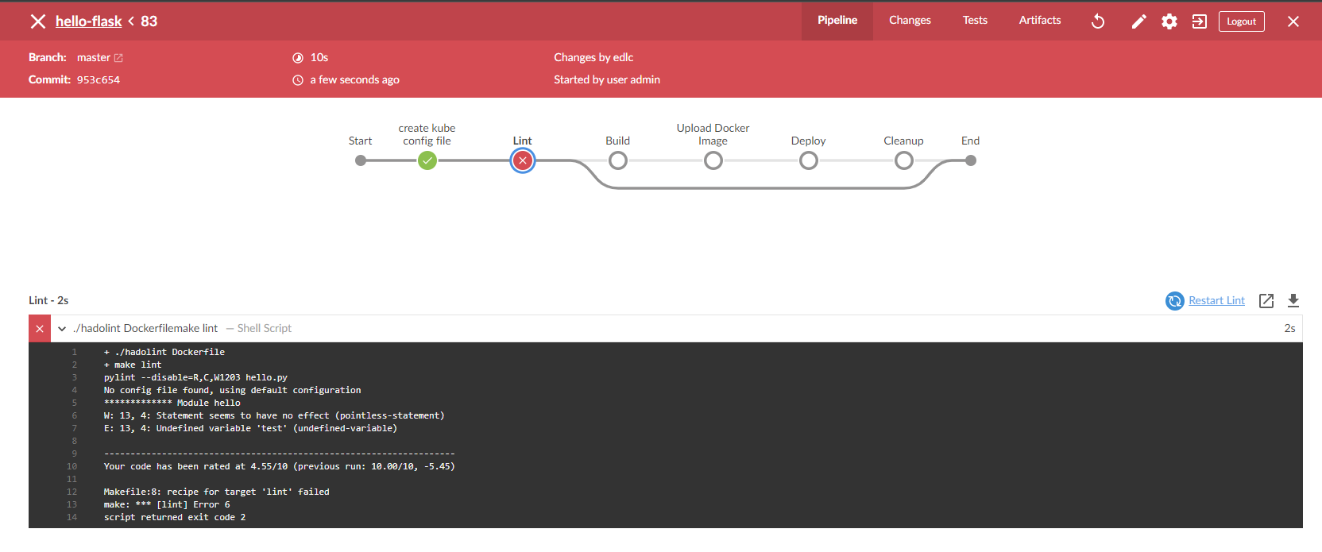

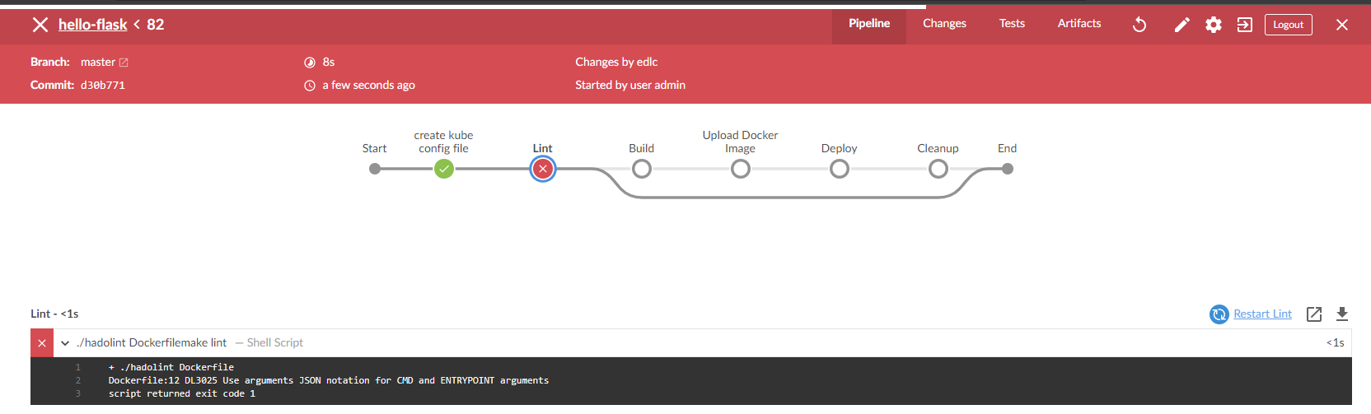

Successful Linting

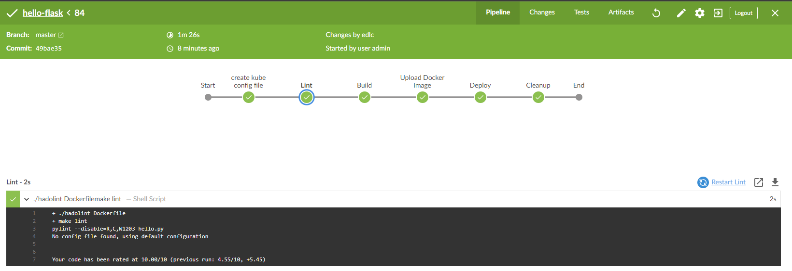

AWS EC2 Instances Summary



AWS EC2 Instance Page (Worker Node 1)

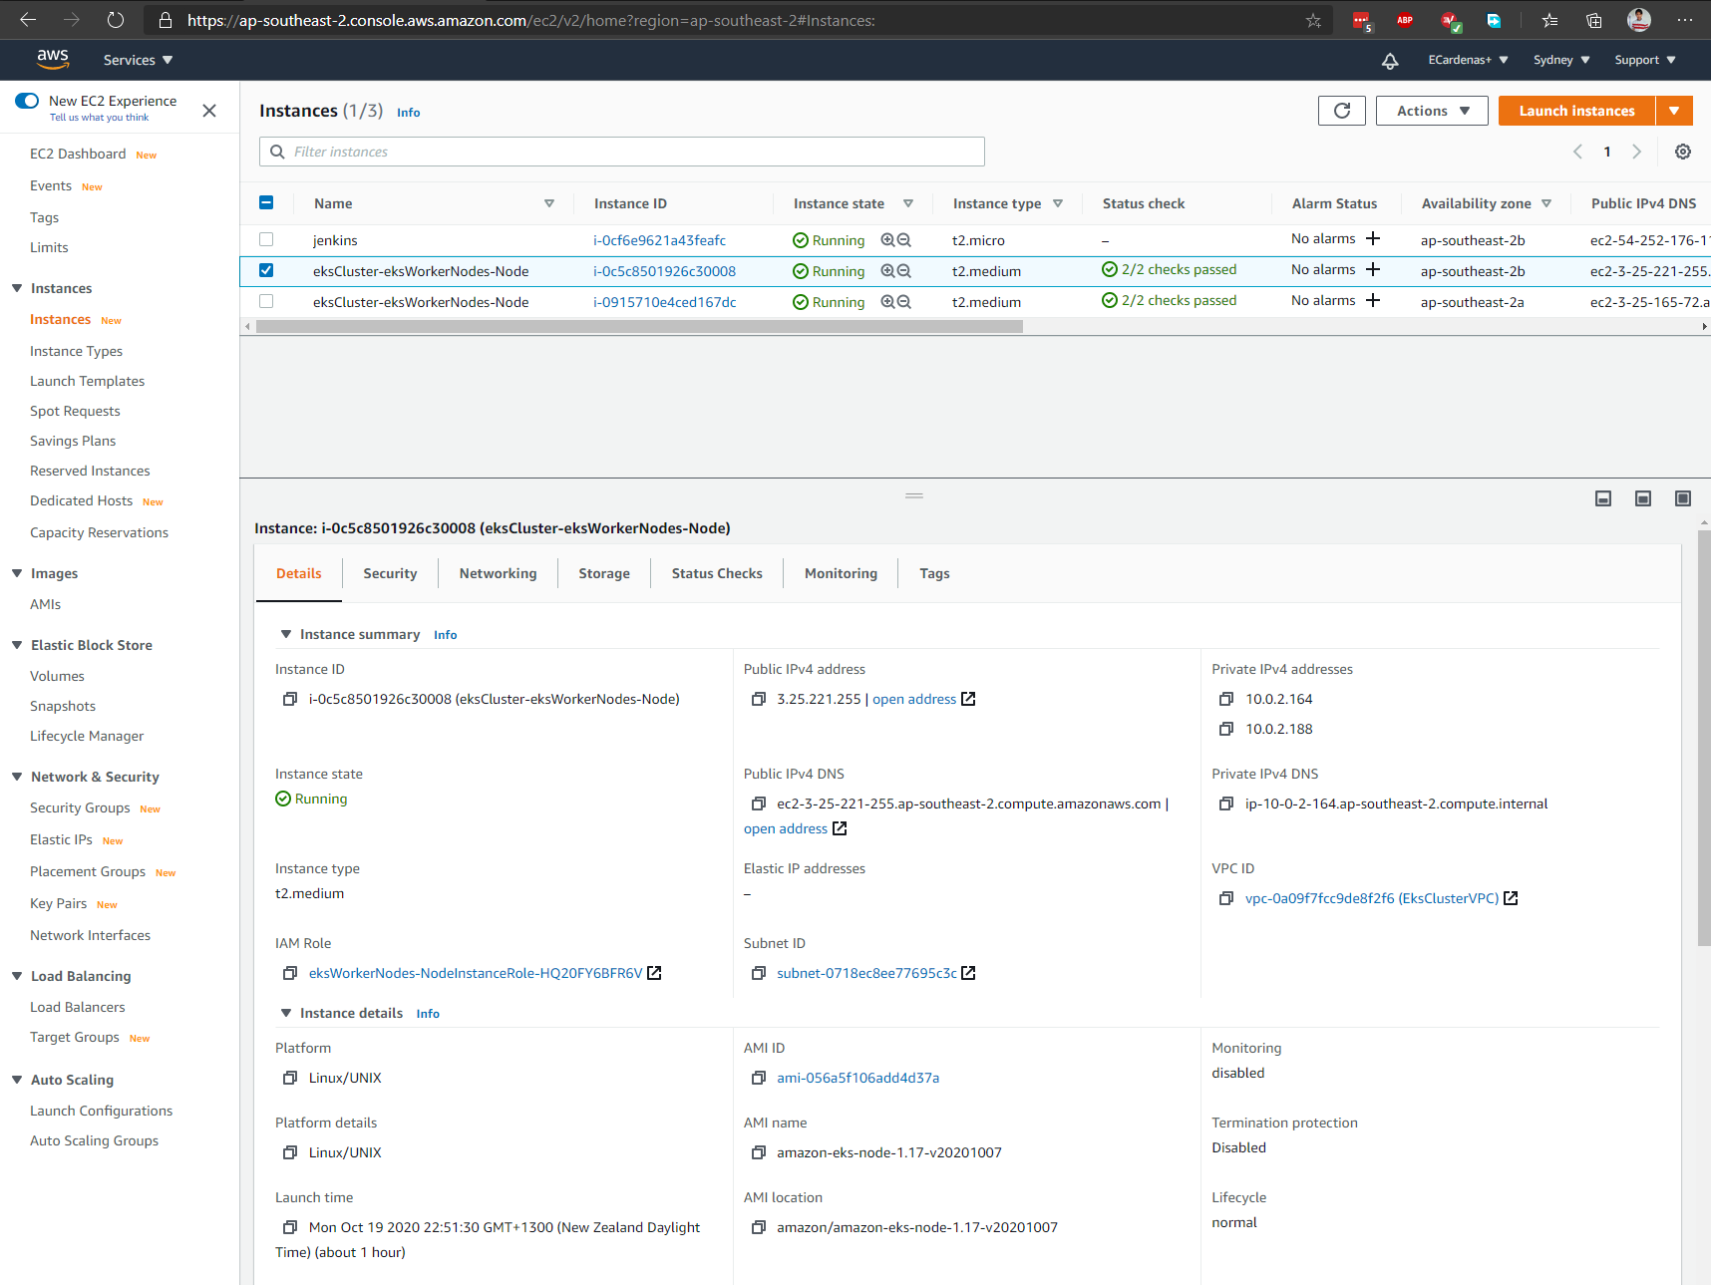

AWS EC2 Instance Page (Worker Node 2)

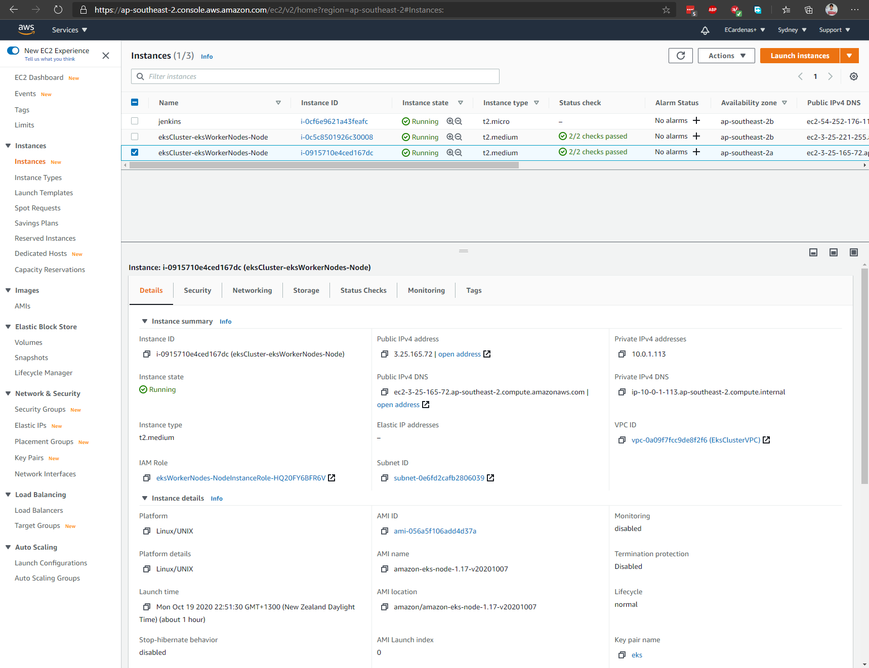

EKS Cluster Details

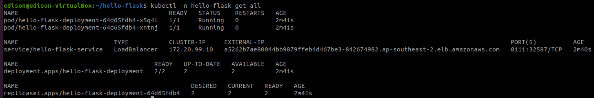

Rolling Deployment

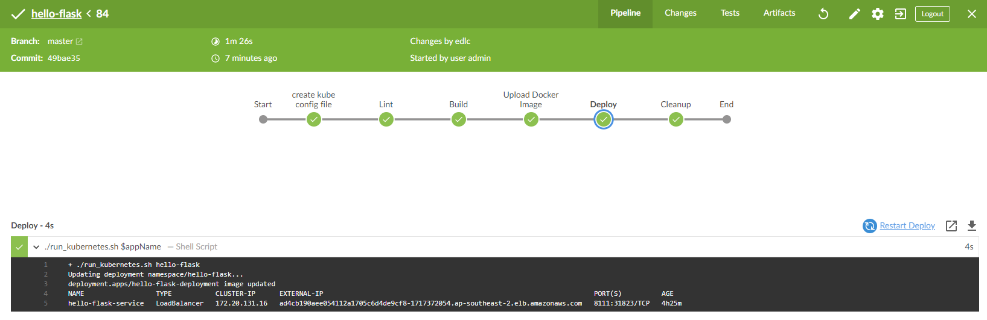

1. Deploy app

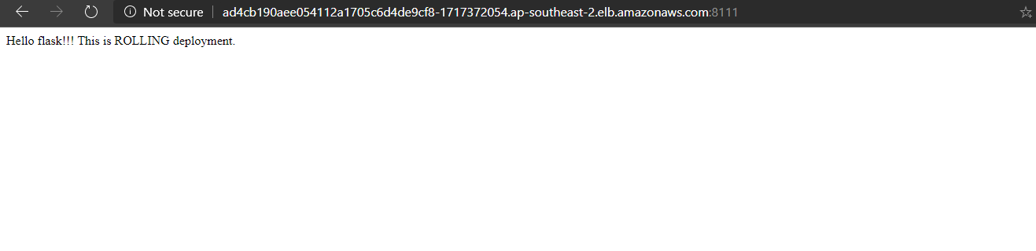

1. Update app

